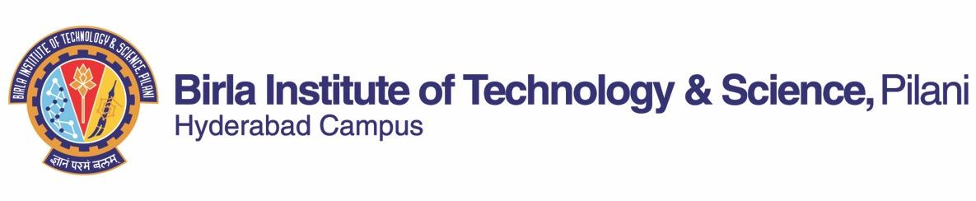

**FIRST SEMESTER 2020-21**

Course Handout (Part II)

Date: 17/08/2020

_

In addition to part I (General Handout for all courses appended to the time table) this portion gives further specific details regarding the course.

|  |  |
| --- | --- |
| *Course No.* | : GS F212 |
| *Course Title* | : Environment, Development and Climate Change |
| *Instructor-in-charge* | : Dr. Lavanya Suresh |
| *Google meet link for the class* | : Available on CMS |

**Scope and Objective of the Course:** This course focuses on the concepts of environment, development, and climate change in the contemporary world. This course focuses on the nature and causes of environmental problems in developing countries. Attention is given to both the causes and solutions of environmental problems and the role of state and non-state actors interacting at local, national and global scales. The objective of the course is to make the students aware of the debates and issues relating to environment, development and climate change. The goal of this course is for the learners to appreciate the people-environment relations and to understand the anthropocentric dynamics of development and climate change.

**Text Books (TB)** Rangarajan, Mahesh. 2006. *Environmental Issues in India: A Reader*. New Delhi: Pearson Education India

***Please Note:* *This is a reading intensive course*.**

**Reference books (Ref):**

1. Adams, W.M. 2009. *Green Development: Environment and Sustainability in a Developing World*. 3rd Edition. New York: Routledge
2. Robbins, P. 2004. *Political Ecology, A Critical Introduction*. Oxford: Blackwell Publishing. (only chapter 1)
3. Bryant, Raymond L., and Sinead Bailey. 1997. *Third World Political Ecology*. London: Routledge (only Introduction, chapter 1 and 2)
4. Krishnan, R., Sanjay, J., Gnanaseelan, C., Mujumdar, M., Kulkarni, A., & Chakraborty, S. 2020. Assessment of Climate Change over the Indian Region: A Report of the Ministry of Earth Sciences (MoES), Government of India.

**Articles and reports:**

1. Lele, Sharachchandra M. 1991. Sustainable Development: A Critical Review. *World Development* 19 (6):607-621
2. Kidd, C. V. 1992. The evolution of sustainability. *Journal of Agricultural and Environmental Ethics*, 5(1), 1-26.
3. Intergovernmental Panel on Climate Change (IPCC). 2014: *Climate Change 2014: Synthesis Report. Contribution of Working Groups I, II and III to the Fifth Assessment Report of the Intergovernmental Panel on Climate Change*. Geneva: IPCC
4. Agarwal, Anil and Narain, Sunita. 1991. *Global Warming in an Unequal World: A Case of Environmental Colonialism*. New Delhi: Centre for Science and Environment
5. Zwarteveen, M. 2015. Regulating water, ordering society: practices and politics of water governance. *Inaugural Lecture, University of Amsterdam*.
6. Documentaries

**Course Format:** The course format will be interactive with regular class discussions and several group exercises, film screening and presentations. Students are expected to prepare in advance with the help of reading material provided.

**Course Plan:**

|  |  |  |  |
| --- | --- | --- | --- |
| **Lecture No.** | **Learning Objectives** | **Topics to be covered** | **Chapter in the text book** |
| 1-5 | Understand the scope and significance of the concept of sustainable development | Sustainable development, sustainability, population dynamics | *Ref a***:** Chapter 1, 2, 3 and 4  *Article a:* Lele, Sharachchandra |
| 6-10 | Acquaint students with the counter currents to sustainable development | Population, resources and sustainability; Counter currents to sustainable development | *Ref a***:** Chapter 5, 6 and 7  *Article b:*Kidd, C. V. (1992). |
| 11-12 | Analyse the relationship between resources and sustainability | Resources and sustainability: Dry land, Forests, Conservation, Rivers, Industry, Energy resources | *Ref a***:** Chapter 8, 9, 10, 11, 12,13 |
| 13-16 | Critically analyse sustainability, policies, environmental movements | Sustainability and policies, Environmental movements, Environment and development | TB:Introduction, Chapter 8 |
| 17-19 | Analyse and evaluate the problems of food security and poverty | Case Study: Food security, poverty, impact and solutions in India | TB: Chapter 11 |
| 20-22 | Examine the theory of commons | Common Property Resource and the Rural Poor | TB: Chapter 14 |
| 23-25 | Appraise and assess water resources and traditional practices | Case study: water conservation | *Ref: Article e:* Zwarteveen, M. 2015 |
| 26-32 | Analyse and evaluate case studies on environment, development and climate change | Case Studies: Gender Environment, Sacred Groves, Ecological conflicts | TB: Chapter 19, 21, 22 |
| 33-36 | Discuss and assess climate change | Development and climate change; Review of international climate negotiations such as Kyoto, Copenhagen and other declarations; | *Report c:* Intergovernmental Panel on Climate Change (IPCC) report. 2014 |
| 37-42 | Discuss and assess the concept of vulnerability, risk and adaptation in the regional context | Climate change models; Regional, national and international climate debates; Technology and greenhouse gas emissions; Regional impacts of climate change and adaptation strategies | *Ref d:* Krishnan, R (2020)  *Article d:* Agarwal, Anil and Narain, Sunita. 1991. |

**Evaluation:**

|  |  |  |  |  |
| --- | --- | --- | --- | --- |
| **Component** | **Duration** | **Weightage (%)** | **Date & Time** | **Nature of Component** |
| Test 1 | 30 min. | 15 | September 10 –September 20 (During scheduled class hour) | Open Book |
| Test 2 | 30 min. | 15 | October 09 –October 20 (During scheduled class hour) | Open Book |
| Assignment | - | 20 | Completed by Third week of October | Open Book |
| Test 3 | 30 min. | 15 | November 10 – November 20 (During scheduled class hour) | Open Book |
| Comprehensive Examination | 120 minutes | 35 | As announced in the Timetable | Open Book |

**Chamber Consultation Hour:** A Google Meet link along with consultation hours will be shared on the CMS

**Notices:** Notices, if any, concerning the course will **only** be displayed on CMS

**Make-up Policy:** Make-up components will be allowed provided there is documentary support for health-related emergencies.

**Academic Honesty and Integrity Policy**: Academic honesty and integrity are to be maintained by all the students throughout the semester and no type of academic dishonesty is acceptable.

**Dr. Lavanya Suresh**

**INSTRUCTOR-IN-CHARGE**